Veronica Rodrigues P7
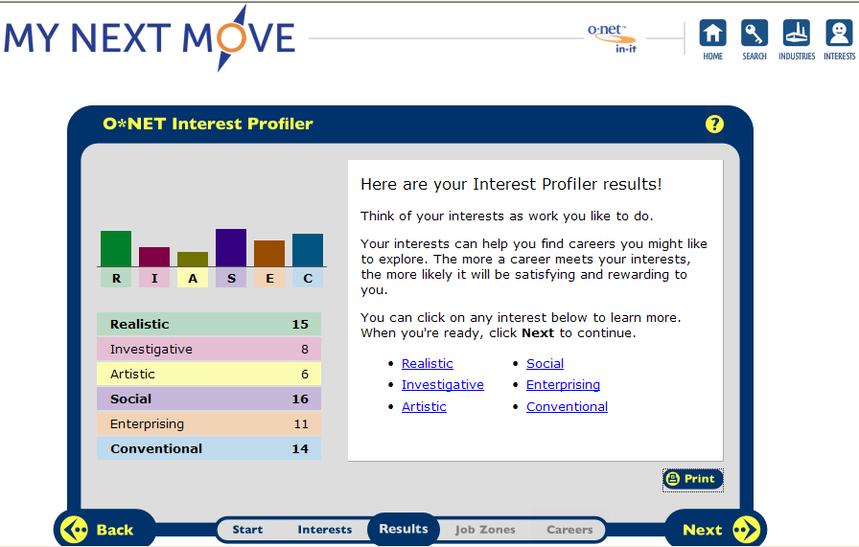

In my Interest Profiler Score Report I was strong in 3 different areas, Realistic, Social, and Conventional. I read over the descriptions of each interest, some are true about my feelings towards a career & others I don’t feel interested in. Realistic seemed to interest me more than the others. People who like Realistic enjoy working with plants and animals, real-world materials like wood, tools, and machinery, also working outside. Many people may look at working with tools & machinery or working outside as a man’s job but woman also can perform this type of job, and perfect it. I think I would like to work in that type of environment. In the test I was also strong in social, people who like teaching, giving advice, helping and being of service to people to help them learn and grow as well. People who are social prefer to work with people rather than working with objects, machines, or information. This type of job sounds interesting but I’m not sure if I would enjoy it much since I’m shy so it would take me sometime to adapt to the job. The last type of career I was strong in was Conventional, working with clear rules, and following a strong leader. I could probably see myself working in that type of work field but I’m not 100% sure.
- Animal Caretaker
- Criminal Investigator or Special Agent
- Bank Teller
- Cashier
- Hotel, Motel, Resort Desk Clerk
- Receptionist
- Massage Therapist
- Child Care Worker
HR1. What is the definition of each occupation that your group has chosen and the nature of the work?
Animal Caretaker: The nature of the work is to take care of each animal no matter the species or size. To groom, bathe, clip the nails, etc. of the animal. Also when the animal is ill or injured you take care of it, even if the cage is broken you repair it.
Criminal Investigator or Special Agent: Police and detectives pursue and apprehend individuals who break the law and then issue citations or give warnings. A large proportion of their time is spent writing reports and maintaining records of incidents they encounter. Most police officers patrol their jurisdictions and investigate any suspicious activity they notice. They also respond to calls from individuals. Detectives, who often are called agents or special agents, perform investigative duties such as gathering facts and collecting evidence.
HR2. What are some of the related occupational fields?
Animal Caretaker: Animal Control workers, Veterinarians, Farmers, Ranchers, Biological Scientists, etc.
Criminal Investigator or Special Agent: Correctional officers, Emergency medical technicians and paramedics, Fire fighters, Private detectives and investigators Probation officers and correctional treatment specialists, Security guards and gaming surveillance officers.
HR3. Which personality type(s) is best suited to the occupations/jobs you have researched?

Animal Caretaker: All animal care and service workers need patience, sensitivity, and problem-solving ability.
Criminal Investigator or Special Agent: personal characteristics such as honesty, sound judgment, integrity, and a sense of responsibility are especially important in law enforcement, candidates are interviewed by senior officers and their character traits and backgrounds are investigated. A history of domestic violence may disqualify a candidate. In some agencies, candidates are interviewed by a psychiatrist or a psychologist or given a personality test. Most applicants are subjected to lie detector examinations or drug testing. Some agencies subject sworn personnel to random drug testing as a condition of continuing employment.

HR4. What kind of education, training and qualifications are required?

Animal Caretaker: Animal trainers often need a high school diploma or GED equivalent. Some animal training jobs may require a bachelor's degree and additional skills. Marine mammal trainers usually need a bachelor's degree in biology, marine biology, animal science, psychology, or a related field. An animal health technician degree also may qualify trainers for some jobs.

Criminal Investigator or Special Agent: Applicants usually must have at least a high school education, and some departments require 1 or 2 years of college coursework or, in some cases, a college degree. Physical education classes and participation in sports are also helpful in developing the competitiveness, stamina, and agility needed for many law enforcement positions. Knowledge of a foreign language is an asset in many Federal agencies and urban departments. Candidates must be U.S. citizens, usually at least 21 years old, and meet rigorous physical and personal qualifications.

HR5. What technology skills are needed to be successful in the career/occupational fields you have explored?

Animal Caretaker: An animal health technician degree also may qualify trainers for some jobs.
Criminal Investigator or Special Agent: Candidates must be U.S. citizens, usually must be at least 21 years old, and must meet rigorous physical and personal qualifications. Physical examinations for entry into law enforcement often include tests of vision, hearing, strength, and agility.
RC1. What does each occupation pay, or what are the average earnings nationally and in this area of the country?
Animal Caretaker: Wages are relatively low. Median annual wages of nonfarm animal caretakers were $19,360 in May 2008. Median annual wages of animal trainers were $27,270 in May 2008.
Criminal Investigator or Special Agent:
Position | Minimum salary | Maximum salary w/o longevity
Police chief | $90,570 | $113,930
Deputy chief | 74,834 | 96,209
Police captain | 72,761 | 91,178
Police lieutenant | 65,688 | 79,268
Police sergeant | 58,739 | 70,349
Police corporal
RC2. What is the projected growth for this career field over the next 10 years? (i.e. will there be more or less jobs like this in the future?)
Animal Caretaker: yes there will be more jobs like this in the future.
Criminal Investigator or Special Agent:
Projections data from the National Employment Matrix
Occupational Title | SOC Code | Employment, 2008 | Projected  Employment, 2018 | Change,  2008-18 |  | Detailed Statistics
 |  |  |  | Number | Percent
Police and detectives | — | 883,600 | 968,400 | 84,700 | 10 | — | —
First-line supervisors/managers of police and detectives | 33-1012 | 97,300 | 105,200 | 7,800 | 8 | [PDF] | [XLS]
Detectives and criminal investigators | 33-3021 | 112,200 | 130,900 | 18,700 | 17 | [PDF] | [XLS]
Fish and game wardens | 33-3031 | 8,300 | 9,000 | 700 | 8 | [PDF] | [XLS]
Police officers | 33-3050 | 665,700 | 723,300 | 57,500 | 9 | [PDF] | [XLS]
Police and sheriff's patrol officers | 33-3051 | 661,500 | 718,800 | 57,300 | 9 | [PDF] | [XLS]
Transit and railroad police | 33-3052 | 4,300 | 4,500 | 200 | 5 | [PDF] | [XLS]
RC3. Please identify local or national organizations that would hire someone in each career field you have explored.
Animal Caretaker: Places you could get hired at is, the zoo, marine biologists, mammal trainers etc.
Criminal Investigator or Special Agent: Job opportunities in most local police departments will be favorable for qualified individuals, while competition is expected for jobs in State and Federal agencies.

ISC1. What are the working conditions or work environment for each job you or your group decided to research (such as work schedule, hours, exempt/salaried or non-exempt/hourly, etc.)?
Animal Caretaker: Low-$8.58 hourly, yearly-$17,900 Median-$10.87 hourly, yearly-$22,600 High-$16.82 hourly, yearly-$35,000
Criminal Investigator or Special Agent: Police work can be dangerous and stressful.
ISC2. Are positions in this career field typically part of collective bargaining units (unions)?
Animal Caretaker: no

Criminal Investigator or Special Agent: yes
ISC3. What kind of opportunities for advancement are there for each career? (i.e. Is there a chance to get promoted, etc.?)
Animal Caretaker: With experience and additional training, caretakers in animal shelters may become adoption coordinators, animal control officers, emergency rescue drivers, assistant shelter managers, or shelter directors. Pet groomers who work in large retail establishments or kennels may, with experience, move into supervisory or managerial positions. Experienced groomers often choose to open their own salons or mobile grooming business. Advancement for kennel caretakers takes the form of promotion to kennel supervisor, assistant manager, and manager; those with enough capital and experience may open up their own kennels. Zookeepers may advance to senior keeper, assistant head keeper, head keeper, and assistant curator, but very few openings occur, especially for the higher level positions.

Criminal Investigator or Special Agent: Police officers usually become eligible for promotion after a probationary period ranging from 6 months to 3 years. In large departments, promotion may enable an officer to become a detective or to specialize in one type of police work, such as working with juveniles. Promotions to corporal, sergeant, lieutenant, and captain usually are made according to a candidate's position on a promotion list, as determined by scores on a written examination and on-the-job performance.
Federal agents often are on the General Services (GS) pay scale. Most begin at the GS-5 or GS-7 level. As agents meet time-in-grade and knowledge and skills requirements, they move up the GS scale. Promotions at and above GS-13 are most often managerial positions. Many agencies hire internally for these supervisory positions. A few agents may be able to enter the Senior Executive Series ranks of upper management.
Continuing training helps police officers, detectives, and special agents improve their job performance. Through police department academies, regional centers for public safety employees established by the States, and Federal agency training centers, instructors provide annual training in self-defense tactics, firearms, use-of-force policies, sensitivity and communications skills, crowd-control techniques, relevant legal developments, and advances in law enforcement equipment.

College Board Research

Massage Therapy
- BCC
- Salter School
- Bancroft

Child Care Worker
- High School

Criminal Investigator or Special Agent
- ITT Tech

I chose this three job careers because they attract most attention to me. I enjoy making people feel relaxed and making sure that their comfortable, whether there on vacation, home, or in a spa. Also, I was the oldest granddaughter in my family so being around my little cousin’s make me happy, so I would enjoy taking care of children at a day care. I also find it interesting to figure out mysteries, and put clues together to help people solve their problems and to put people behind bars who deserve to be.

